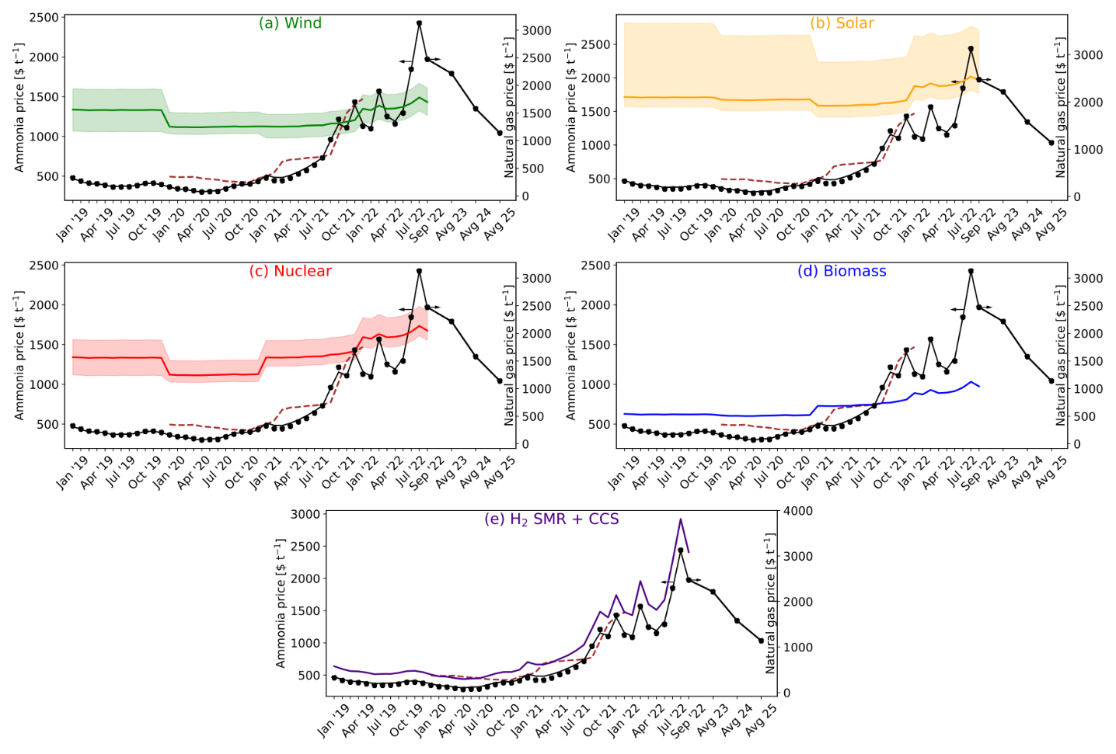Fig. 1 Production cost comparison of fossil (BAU) ammonia vs green ammonia with hydrogen from (a) water electrolysis using on-shore wind electricity, (b) water electrolysis using solar electricity, (c) water electrolysis using nuclear electricity, (d) biomass gasification, and (e) SMR + CCS. The brown dashed line in plots (a) – (e) represent the market price of ammonia. The shaded region in plots (a) – (c) is the sensitivity analysis due to the levelized cost of hydrogen (table 5). All the data points are shown in table 8.
- In the past year, monthly average natural gas prices have increased from 560$ t⁻¹ in July 2021 to 2300$ t⁻¹ as of July 2022. Similarly, the price of grid electricity has almost quadrupled (table 1). The major reasons for this trend are the aftermath of COVID-19, soaring inflation, climate change, and war on Ukraine.
- In the case of BAU ammonia, every ton of ammonia produced consumes 0.53 ton of natural gas and 940 kWh of electricity. As of September 2022, cost of production for BAU ammonia was around 1965$ t⁻¹ which is three times higher in comparison to July 2021.
- When natural gas prices reach around 1400$ t⁻¹, ammonia with hydrogen from water electrolysis using on-shore wind electricity becomes cost competitive with BAU ammonia. Based on the monthly average natural gas prices, ammonia production via wind electrolysis has been cheaper than or similar to BAU ammonia for seven months since October 2021 (table 8).
- The solar scenario is only feasible around the peak of natural gas prices in August 2022. This can be attributed to lower capacity factors (16.1% to 17.5%) in comparison to wind electricity (35.6% to 39%) resulting in higher levelized costs of hydrogen.
- The cost of construction and operation of nuclear power plants is becoming increasingly expensive and difficult. Therefore, even though they have a higher capacity factor of around 95%, the cost of production of electricity from nuclear energy is increasing. Notably, ammonia from nuclear electrolysis was cheaper only for three months from January 2022 to September 2022.
- The biomass scenario is the best performing case out of all the alternatives. At natural gas prices of around 690$ t⁻¹, the biomass scenario is already economically more feasible than BAU ammonia. As of September 2022, BAU ammonia is two times more expensive than ammonia using hydrogen from biomass.
- Hydrogen from SMR + CCS is always more expensive than BAU ammonia due to the inclusion of CCS and also the additional nitrogen feed required in this scenario. Whereas, in BAU ammonia the nitrogen comes from air used in the autothermal reformer.
- Looking at the current situation, natural gas prices are predicted to remain high (2216 – 1579$ t⁻¹) for the next few years. On the other hand, the prices of renewable energy technologies are expected to decrease. Therefore, ammonia production from wind and biomass routes could be the most promising technologies in the foreseeable future.
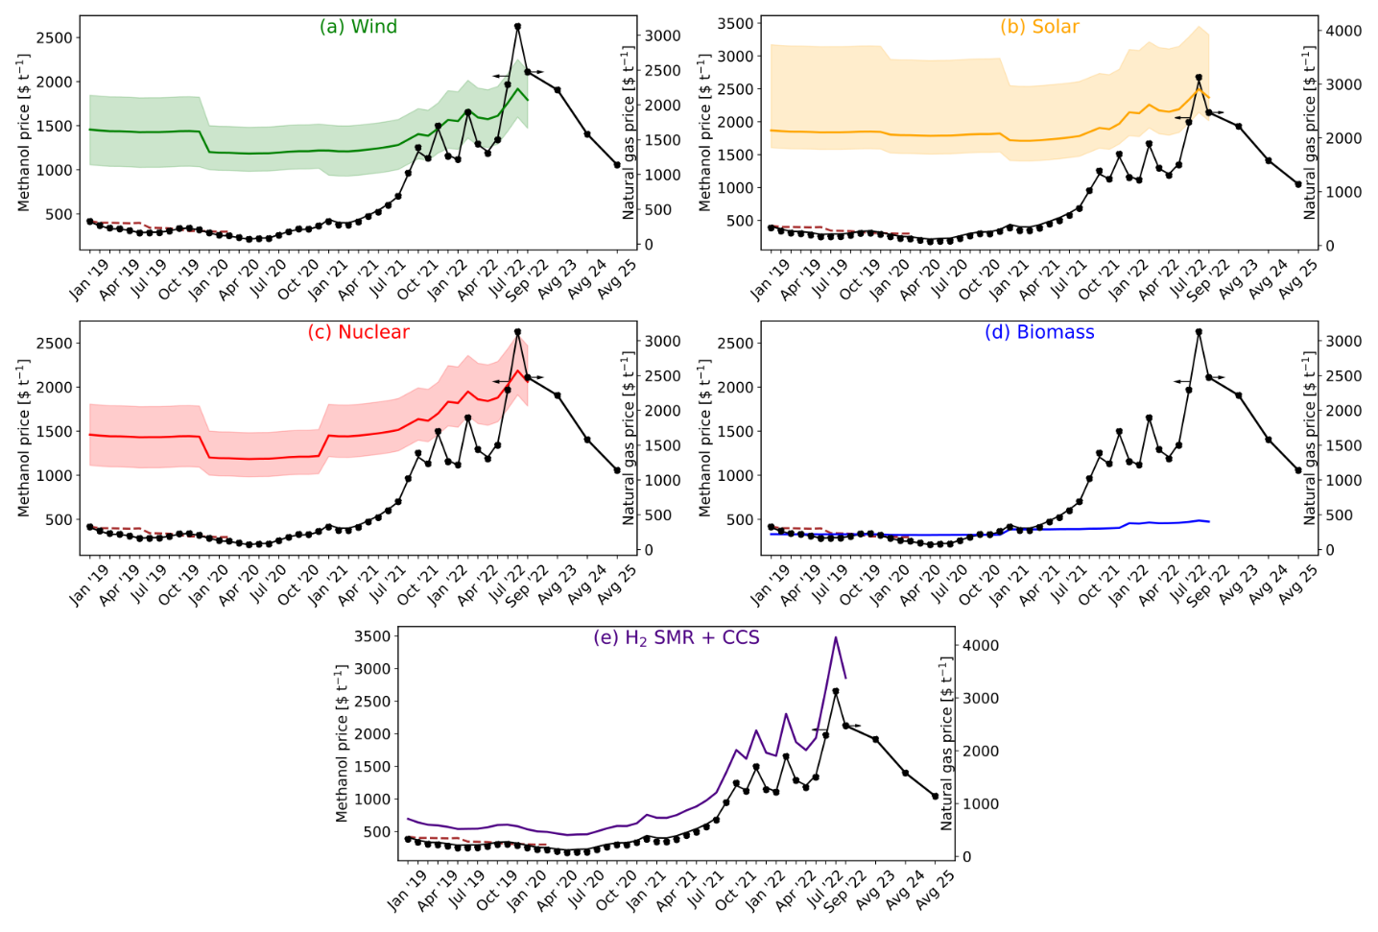Fig. 2 Production cost comparison of fossil (BAU) methanol vs green methanol with hydrogen from (a) water electrolysis using on-shore wind electricity, (b) water electrolysis using solar electricity, (c) water electrolysis using nuclear electricity, (d) biomass gasification, and (e) SMR + CCS. The brown dashed line in plots (a) – (e) represent the market price of methanol. The shaded region in plots (a) – (c) is the sensitivity analysis due to the levelized cost of hydrogen (table 5). All the data points are shown in table 9.
- In the case of BAU methanol, every ton of methanol produced consumes 0.67 tons of natural gas and 708 kWh of electricity. Therefore, similar to ammonia, the cost of production for BAU methanol has increased sharply. In comparison to July 2021, the cost of production of methanol rose by 243% in September 2022.
- For the cases of hydrogen from water electrolysis using (a) on-shore wind, (b) solar, (c) nuclear, and (e) SMR + CCS, carbon dioxide from Direct Air Capture (DAC) is used as a feed. For every ton of carbon dioxide captured, 0.11 ton of natural gas is required.
- At natural gas prices of around 1700$ t⁻¹, the wind scenario is economically competitive in comparison to BAU methanol. Also, considering low prices of wind electricity, at natural gas prices of 1400$ t⁻¹, methanol production with hydrogen from water electrolysis using on-shore wind electricity and carbon dioxide from DAC is more feasible.
- The solar scenario follows a similar trend to that seen for ammonia and is only feasible at the peak of natural gas prices (August 2022) due to lower capacity factors and higher cost of levelized hydrogen.
- For methanol with hydrogen from water electrolysis using nuclear energy, cost of production is only cheaper than BAU methanol for three months from July 2022 to September 2022.
- The biomass scenario is again the best performing case out of all the alternatives considered. In this case, 1.74 tons of biomass (straw) and 100.5 kWh of electricity is required per ton of methanol produced. As of September 2022, production of BAU methanol is 4.4 times more than that of methanol from biomass.
- For the case of hydrogen from SMR + CCS, the cost of production is on average 67.8% higher than BAU methanol due to additional cost of CCS and carbon dioxide from DAC.
- Similar to ammonia, methanol production via wind and biomass routes are expected to be cost competitive with BAU methanol in the coming future.
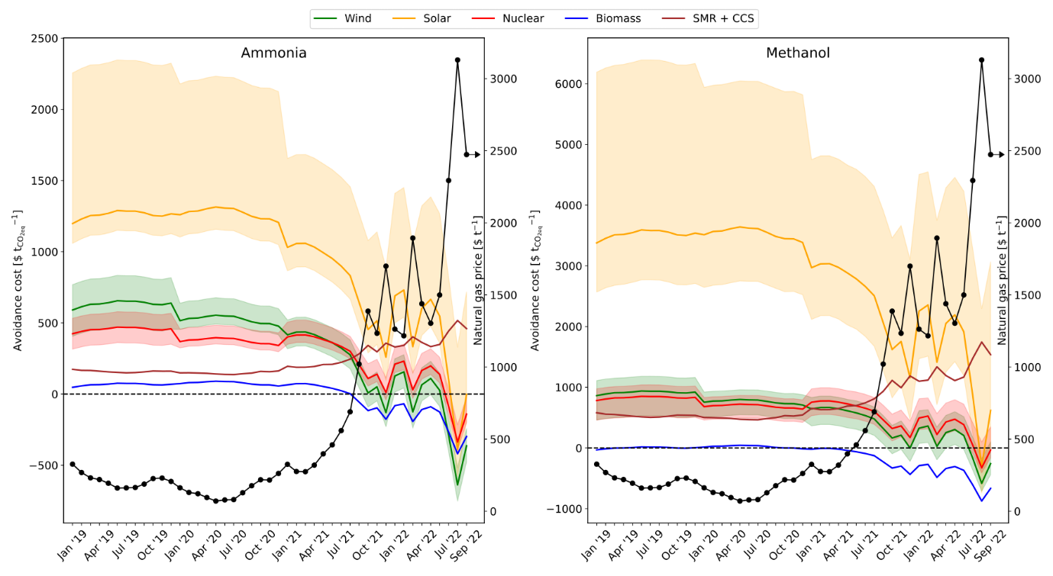
Fig. 3 CO₂ avoidance costs for (a) ammonia, and (b) methanol. The GWP values used are given in table 6 and table 7 for ammonia and methanol, respectively.
- ${\text{CO}}_{\text{2}}\text{ avoidance costs =} \frac{{\text{P.C}}_{\text{alt}}\text{ -} {\text{P.C}}_{\text{BAU}}}{{\text{GWP}}_{\text{BAU}}\text{ -} {\text{GWP}}_{\text{alt}}}$
- ${\text{CO}}_{\text{2}}\text{ avoidance costs in \$} {\text{t}}_{{\text{CO}}_{\text{2}}\text{eq}}^{\text{-1}}$
- $\text{P.C is the production cost in \$ }{\text{t}}^{\text{-1}}\text{ of product}$
- $\text{GWP is the global warming potential in} {\text{t}}_{{\text{CO}}_{\text{2}}\text{eq}} {\text{t}}^{\text{-1}}\text{ of product}$
- $\text{alt are the alternative routes of production}$
- $\text{BAU is the business as usual route of production}$
- The avoidance costs follow an inverse relation to the natural gas price. As natural gas prices increase, we spend less money for every ton of carbon dioxide emissions avoided.
- Negative avoidance costs signify that the cost of production of BAU ammonia or BAU methanol are higher than the alternative route. As a result, we save money for every ton of carbon dioxide emissions avoided.
- Since September 2021, we save around 56$ to 420$ per ton of carbon dioxide emissions avoided by using the biomass route for the production of ammonia. Similarly, from November 2020 for methanol via biomass, savings oscillate from 0.26$ to around 874$ per ton of carbon dioxide avoided.

Table 1 Average monthly prices of natural gas and electricity
Month | Natural gas  [$ t⁻¹] | Electricity  [$ MWh⁻¹]
Jan '19 | 326.18 | 49.41
Feb '19 | 268.54 | 42.81
Mar '19 | 231.45 | 30.61
Apr '19 | 219.83 | 36.97
May '19 | 193.92 | 37.83
Jun '19 | 160.41 | 32.50
Jul '19 | 161.75 | 39.71
Aug '19 | 164.43 | 36.82
Sep '19 | 188.11 | 35.77
Oct '19 | 226.09 | 36.95
Nov '19 | 230.11 | 41.00
Dec '19 | 206.43 | 31.97
Jan '20 | 162.20 | 34.98
Feb '20 | 130.02 | 21.91
Mar '20 | 121.53 | 22.52
Apr '20 | 94.73 | 17.05
May '20 | 70.60 | 17.60
Jun '20 | 78.19 | 26.23
Jul '20 | 80.43 | 30.07
Aug '20 | 127.79 | 34.89
Sep '20 | 176.49 | 43.68
Oct '20 | 218.49 | 33.96
Nov '20 | 216.26 | 38.80
Dec '20 | 261.84 | 43.55
Jan '21 | 324.84 | 52.79
Feb '21 | 275.24 | 48.71
Mar '21 | 273.90 | 47.18
Apr '21 | 319.48 | 53.66
May '21 | 398.12 | 53.33
Jun '21 | 460.22 | 74.13
Jul '21 | 558.97 | 81.29
Aug '21 | 689.44 | 82.81
Sep '21 | 1020.53 | 128.34
Oct '21 | 1387.37 | 139.54
Nov '21 | 1234.11 | 176.25
Dec '21 | 1699.25 | 220.96
Jan '22 | 1262.71 | 167.87
Feb '22 | 1216.69 | 128.78
Mar '22 | 1894.06 | 251.76
Apr '22 | 1438.75 | 166.00
May '22 | 1303.37 | 177.51
Jun '22 | 1499.52 | 218.18
Jul '22 | 2293.52 | 315.26
Aug '22 | 3129.51 | 469.35
Sep '22 | 2473.28 | 346.12

Table 2 Average CEPCI indexes
Year | CEPCI
2019 | 607.5
2020 | 596.2
2021 | 708.0
2022 (average till July) | 816.1

Table 3 Cost parameters used in economic calculations. All costs are presented in $_{2019.}
Component | Average | Low | High
Water [$ t⁻¹] | 0.18 | - | -
Cooling water [$ GJ⁻¹] | 0.38 | - | -
CO₂ capture and storage [$ t⁻¹] | 15.84 | - | -
CO₂ emissions [$ t⁻¹] | 30.00 | - | -
Nitrogen [$ t⁻¹] | 91.06 | - | -
Carbon dioxide – DAC [$ t⁻¹] * | 137.35 | 67.85 | 206.85
*These prices do not include the cost of natural gas required for the capture of carbon dioxide. 1 ton of carbon dioxide requires 0.11 ton of natural gas.

Table 4 Levelized cost of electricity in $ MWh⁻¹ and capacity factors (CF)
 | 2019 |  |  |  | 2020
 | Average | Low | High | CF | Average | Low | High | CF
Wind - on shore | 67 | 37 | 96 | 35.6 | 45 | 35 | 65 | 36.0
Solar PV | 68 | 52 | 190 | 17.5 | 57 | 39 | 163 | 16.1
Nuclear | 87 | 63 | 112 | 95.0 | 69 | 42 | 102 | 95.0

 | 2021 |  |  |  | 2022
 | Average | Low | High | CF | Average | Low | High | CF
Wind - on shore | 42 | 26 | 59 | 39.0 | 48 | 30 | 68 | 39.0
Solar PV | 48 | 29 | 120 | 17.2 | 55 | 33 | 138 | 17.2
Nuclear | 82 | 50 | 121 | 95.0 | 94 | 57 | 140 | 95.0

Table 5 Levelized cost of hydrogen in $ t⁻¹
 | 2019 |  |  |  | 2020
 | Average | Low | High | Average |  | Low | High
Wind - on shore | 6296 | 4761 | 7780 | 5138 |  | 4626 | 6162
Solar PV | 8444 | 7625 | 14688 | 8278 |  | 7357 | 13703
Nuclear | 6316 | 5053 | 7579 | 5138 |  | 4626 | 6162
Biomass with CCS | 2270 | - | - | 2228 |  | - | -

 | 2021 |  |  |  | 2022
 | Average | Low | High | Average |  | Low | High
Wind - on shore | 4894 | 4075 | 5764 | 5641 |  | 4697 | 6644
Solar PV | 7507 | 6534 | 11192 | 8653 |  | 7532 | 12900
Nuclear | 6102 | 5494 | 7317 | 7033 |  | 6333 | 8434
Biomass with CCS | 2646 | - | - | 3049 |  | - | -

Table 6 Global warming potentials in kg_{CO2eq} kg⁻¹ ammonia for all scenarios
Process | GWP
BAU | 2.180
Wind | 0.712
Solar | 1.140
Nuclear | 0.126
Biomass | -1.140
H₂ SMR + CCS | 1.220

Table 7 Global warming potentials in kg_{CO2eq} kg⁻¹ methanol for all scenarios
Process | GWP
BAU | 0.658
Wind | -0.556
Solar | 0.226
Nuclear | -0.686
Biomass | -1.790
H₂ SMR + CCS | 0.169

Table 8 BAU ammonia vs green ammonia. All prices are presented in $ t⁻¹. The values highlighted in green are the cases where the alternative route for ammonia production is cheaper than or similar to (not more than 5%) BAU ammonia.
Table 9 BAU methanol vs green methanol. All prices are presented in $ t⁻¹. The values highlighted in green are the cases where the alternative route for methanol production is cheaper than or similar to (not more than 5%) BAU methanol.

